ABOUT THE TRAINEE
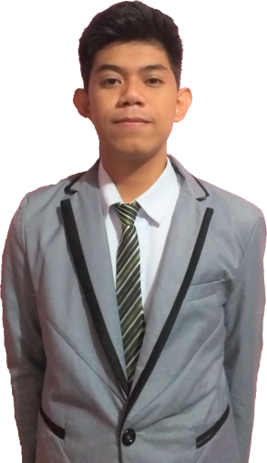

Personal
1. Full Name: Christian Ken Planas
2. Home Address: P-1, Suyatan Sabang, Surigao City
3. Civil Status: Single
4. Date of Birth: April 30, 2000
5. Age: 18
6. Citizenship: Filipino
7. Contact Nos.: 09661546900
8. Email Add: chriszakharov@gmail.com
A. EDUCATION
-Educational Attainment and Academic Honors
Academic Level | School Address | Years Attended | Academic Distinctions/Awards
Elementary | SCPS | 2006-2012 | Completer
Junior High School | CRSHS & SDNNHS | 2013 - 2016 | Completer
B. ACCOMPLISHMENTS/AWARDS
Levels | Awards | Date
International
National
Regional
Division
School
C. SKILLS AND TRAININGS
Skills | Trainings | Date and Venue
Innovation skills, Entrepreneurship, Financial Literacy, Communication skills, Negotiation skills, Networking | 2018 ASEAN Business Forum and Trade Expo Mindanao Business Conference | August 15-17,2018| Caraga Regional Science High School  September 13-15, 2018| Big 8 Corporate Hotel, Tagum City

Signature: _____________________________

CRSHS SHS Immersion

