SITUATION
Task 1 (For All Classes). After reading the news items below, answer the questions that follow. Send your work to your respective GEC 17 Google classrooms (Classes A and B) and in a short paper for Class C following the format:
Name: Christian Ken Planas Course and Year: BSIT-2C
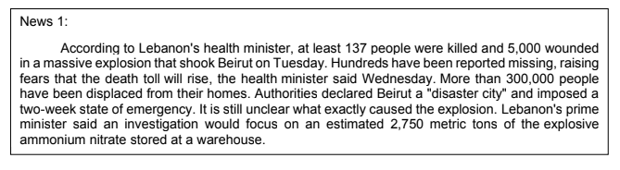

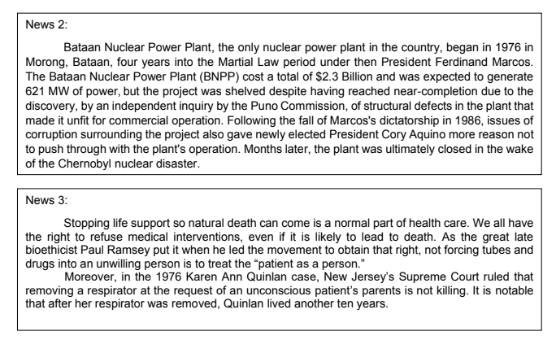

Write your observations on the above new items:
1. What characteristics do these news items have in common?
- The characteristics present in the news consists of the advantages and disadvantages of technology and science.
2. Write down some disadvantages of science and technology that were presented in the news.
- For starters, power plants are great. But what if power plants become unstable?
- Life support systems can become inhumane.

3. Would you allow Euthanasia or mercy killing on a dying loved one?
- Yes, since its more painful to see them suffer while dying slow than to see them die a swift painless death where they could be at peace.

4. Are science and technology really important and indispensable factors in our everyday life? Explain.
- Yes they are, whether you like it or not. Science and technology are the building blocks into the future, without them we would still be stuck living like medieval age. Without science and technology, we wouldn’t have these wonderful medicines and cures for diseases and to even explore outer space.

