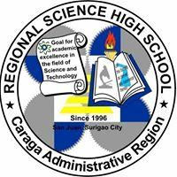

Department of Education
Division of Surigao City

CARAGA REGIONAL SCIENCE HIGH SCHOOL
SENIOR HIGH SCHOOL DEPARTMENT
P-10, Barangay San Juan, Surigao City
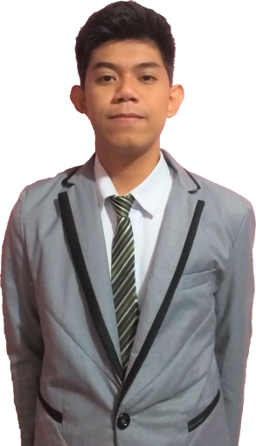
IMMERSION SCHEDULE AND COMPANY ASSIGNMENT

Name of the Student: Christian Ken Planas
School: Caraga Regional Science High School
Track: Acdemic Track
Stand: Accountancy, Business and Management
Immersion Adviser: Fernalyn C. Mozar, MBA
Batch No.: II
Immersion Date: December 13,2018 – February 27, 2019
Assigned Are/ Unit: Department of Trade &Industry-Finance Department
Trainer: Maricel Tilbe

